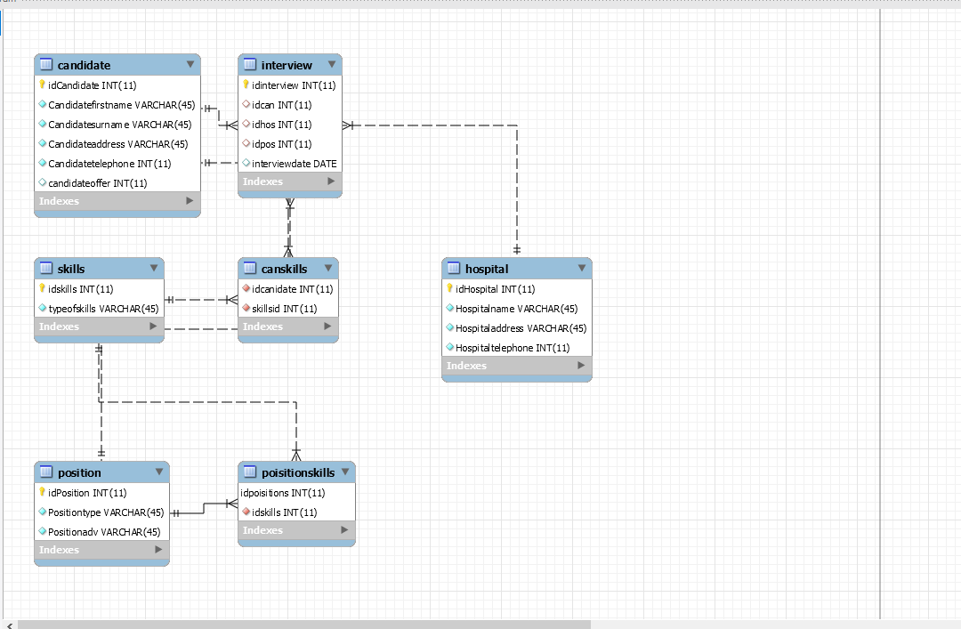

* I made the assumption that we need a positonskilled table as we needed to know the requirements for the job in the hospital.
* As I added positionskilled needed for the job and if you have the skill you are up for the interview.
* I made another assumption that we needed a candidate skilled table for their skilled to be showed as if they will get the interview or not.
* Candidate offer I add it in as to check if they got the job or not and so we know what happened in the interview
* I made forgien keys for skillsid and connect it to another tables like canskills and positionskills.
* We made the skill table to have the skills need in the hospital
* We made positionskill to get the position aivable and require skill
* We made canskills to get the candidate and what skills they have
* I made 7 tables in this project with 16 stored procedures as requested by the lecturer.
* I put 3 colums in position, 2 in positionskills, 2 canskills, 2 in skills, 4 in hospital, 5 in interview, 6 in candidate. As I connected 3 them with forgien key.
* The relationship between the tables and date is the forgien key called the skillid.